East Lancs Inter Club League- Race 3
Accrington - Blackburn – Darwen – Ribble Valley - Riversway - Trawden
Hosted by Riversway Roadrunners – 1st September
Timetable
18:00 Arrival time from 6pm
18:45 Pre-race brief
19:00 Race start
19:45 Race finish & Refreshments
20:00 Results & Team Prizes followed by Serie Awards

Location: Vernon Carus Sports Club
Factory Lane, Penwortham, Preston, Lancs, PR1 9SN

Route: 4.2 miles on park paths around Avenham and Miller park. The course takes you across Preston’s brand new Tram Bridge at mile 1 (Opened in June this year)
At mile 3 there are a few steps to climb, these steps are safe and will be marshalled.
Route is easy to follow, with marshals throughout the course
We share the route with walkers and bikes, please show patience & courtesy, with safety our priority.
We will have a photographer enroute – photographs will be shared free of charge a few days after the race!

Requirements of the Runners:
- Please try and car share where possible. We have a car park allocated for the run which has around 55-60 spaces – the cost of this car park is £2 per car, please bring cash! Once full there is parking on local streets.
- PLEASE DO NOT PARK on the road (FACTORY LANE) leading up to the car park – there are cricket and football matches on at the same time and emergency vehicles may need access to the ground – this has been a direct request from the club.
- Toilets are avalable at the start and end.
- Club vests of the same colour MUST be worn.
- Please stay in order when you finish (similar to Parkrun). Your finishing position will be logged by club vest and gender at the finish line.
- Be courteous to all runners, we aim to create a social atmosphere with a friendly rivalry.

Bag Drop
You can leave a bag at the start/finish area, there will be a covered gazebo available.

Results/Presentation
Results will be announced on the night for the this run and given it is the final race of this year’s inaugural series we will be presenting the series awards at the end of this race.

We have secured an indoor function room area with a fully working bar for our presentation so I would encourage runners to attend the presentation and purchase a drink if they want (its helps the club out)

It’s a team event, you are representing your club so NO individual prizes or timings.

Car parks will be marshalled and are located at the end of Factory Lane

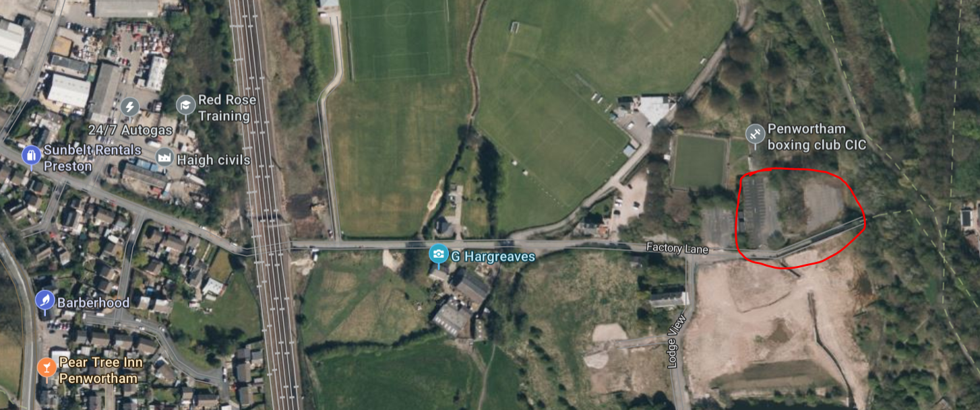

Factory Lane, Penwortham, Preston, Lancs, PR1 9SN

